Programming Assignment 1 –
Bag-based Dictionary
  - Implement a dictionary using a Bag—Project 4.7 in the text (modified)
Use the bag ADT provided to create an array-based implementation for bags (you may NOT use a vector). Then use your bag to implement the dictionary ADT provided you. The bag your dictionary uses to store its values must be of type KVpair. For example, “ABag<KVpair<Key, E>> dictionary;” is an example of an instantiation of a bag that stores KVpair types.
DO NOT MAKE ANY CHANGES TO THE ADT FILES! The ADT files you submit with your assignment must match EXACTLY the files I have provided, or you will not get any credit for the assignment.
To get full credit for the assignment you must
- Incorporate one or more smart pointers and tell me where they are in your Approach document – if you make me look for them you won’t get credit for them. If you don’t know what smart pointers are then you’ll need to do some research.
- Use Git to keep track of your changes. See Git with Visual Studios tutorial and then look below to see how to demonstrate you used Git with your project. At the end of each coding session make a Git commit.
- Also, since you will need to use C++ templates extensively to complete this assignment, here is a link to a number of tutorials that you may find helpful: https://www.youtube.com/results?search_query=c%2B%2B+templates
You are free to install GitHub’s CoPilot into your Visual Studio development environment to help you complete this (and the remaining assignments). If you don’t have a GitHub account, I recommend you create one using your Liberty email account so that you can install CoPilot for free. Note that you are not allowed to use Microsoft’s CoPilot, only the GitHub CoPilot extension.
You are also allowed to collaborate with one other 215 student, provided they agree, and they are in the same 215 section as you. If you do collaborate, be sure to mention who your partner is in your Approach Document. If you do work in pairs, each student must submit his/her own assignment. One student cannot submit for both.
Test your bag and dictionary implementations with the bagtestmain.cpp file I’ve provided for you. If you are not able to fully implement all the functions of the dictionary and/or bag, you may modify the tests in bagtestmain.cpp to only exercise those functions you were able to complete.
You will only get credit for those methods you test and display, so be sure you don’t leave any out.
Also, you cannot add any public functions to your bag and dictionary implementations beyond those specified in the ADTs.
This assignment (and all the following assignments) must be submitted using Visual Studios 2026 Community. Submit to Canvas your entire Visual Studios project directory as a zip file which should include all the following files:
- ABag.h // Your bag-array implementation which must inherit the Bag class
- BDictionary.h // Your Dictionary-bag implementation which must inherit the // Dictionary class
- bagtestmain.cpp // The test driver I have provided for you
- bagADT.h // The bag ADT I gave you – it must be unchanged
- dictionaryADT.h // The dictionaryADT I gave you – it must be unchanged
- kvpair.h // The kvpair class I gave you – it must be unchanged
Also include in your zip file:
- screen_shots.docx/txt // Word document with screen shot(s) showing
// program in action or a text file showing the test
// program's output.
- Approach.docx // This is a Word document that reads like a lab notebook
// laying out what you plan to accomplish each day as you incrementally
// build your solution. It should be future tense in nature,
// and it should be at least 500 words in length.
- GitScreenShot.png // This is a screen shot of the Git “Manage Branches” screen in Visual
// Studios that demonstrates you have used Git in Visual Studios to
// track your changes. I want you to “commit” every time you complete
// a function or when you are finished for the day. I should see multiple
// commits for your project.
Note: If your ABag does not inherit Bag and/or BDictionary does not inherit Dictionary, you will not receive any credit for your work.
Your test program must exercise every function of the dictionary. For any function whose functionality is not obvious you must explain in your Word document how your test output demonstrates that function. See me if you have questions.
See Canvas for the assignment due date.
Rubrics:
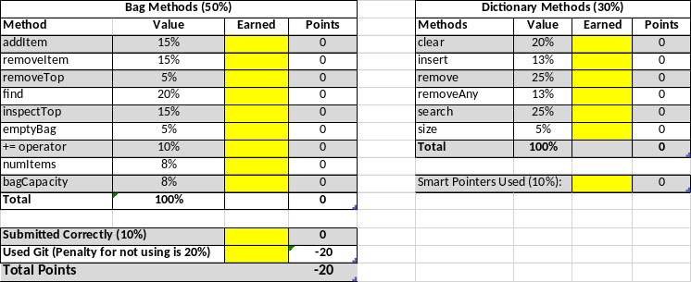
- Program must run to get any points. By “run” I mean that at you must at least get one or more of the bag methods working (and your program must demonstrate that functionality). Additionally, your ADT files must not be changed in ANY WAY and must be inherited, or you will not get credit for the assignment!!!
Tips for Success
Start by working on your “Approach” first. Once you are satisfied with your approach, then start building your program incrementally. Start with the bag and increment one feature at a time (you’ll have to stub out the features the ADT requires that you are not ready to implement yet) starting with the constructors and then working your way down the feature list using common sense to figure out which features need to be implemented first. Try your bag out with the various parameter combinations I want you to test with (<int, string> and <string, int>). When you are satisfied the bag is working then move on to the dictionary, again implementing and testing function by function.
Don’t wait until the last minute. You’ll find that many of your problems you will solve while you are away from your computer and have a chance to think about the error you are seeing. This takes time.
Note: KVpair, which uses the == operator for comparing the key values, will only accept objects that have also implemented the == operator. This class has been tested with the following types:
    - string
    - int

Debugging your code
A big part of this assignment is debugging your code, so do not expect your instructor to do this for you. Having completed the pre-requisite courses for this class, you should already have some experience finding coding errors and fixing them. This class will give you plenty of opportunities to further refine those skills and you can only do that by wrestling with the problem. Here are some debugging tips:
- Build a little, test a little. Don’t write all your code before you start debugging it. Break your work into logical chunks that can be compiled and debugged and build them one at a time. For this project, I would start by building the Bag class and implementing the addItem() function first. Once I get that function working properly, then I would move on to another Bag function. The idea is to build and test a function one function at a time. That way, if you run into an error, you know where to look.
- Learn to use the debugger if you haven’t already. The debugger allows you to step through your code one step and a time and see what happens in memory while you’re doing it. When students come to me with problems, I first try to isolate where the problem is logically based on what the program is doing and then I use the debugger to find the actual fault. Here is an excellent video tutorial on the Visual Studios debugger: How to DEBUG C++ in VISUAL STUDIO.
- Be willing to walk away from your computer and give your mind a rest. I find that the solution to a problem often comes to me while I am doing something else. I have never regretted stepping away from my computer to let the problem “percolate” in my mind, but I have often regretted not doing this. This is one of the reasons you should never wait till the last minute to start working on your program; by doing that you are not giving yourself the time to walk away.
Course Learning Outcomes Alignment

